SCUBA-2 Block Specification
wbs_frame_data

Revision History:
Rev. 1.0 DA Initial Release
Rev. 1.1 MA added document number and revision history

September 15, 2006
Table of Contents

1. Block Overview 3
1.1 Block Location and Block Interface Within System 3
1.2 Block Functionality / Features 3
1.3 Block Dataflow 4
1.4 Wishbone Requests 4
2. Block Interfaces 6
2.1 Interface Signal Description 6
2.2 Data output MUX architecture 7
2.3 Interface Protocol and Timing 7
3. High-Level Description 8
3.1 State Machine Description 8
3.2 State Machine Outputs 9
4. Files of the Block 11
4.1 Source Code 11
4.1.1 Wbs_frame_data.vhd 11
4.2 Header Code 11
4.2.1 Wishbone_pack.vhd 11

Block Overview

Block Location and Block Interface Within System
This block is located on the readout card FPGA. It is a wishbone slave and it interfaces with the following blocks:

- dispatch (wishbone master)
- flux_loop_ctrl (8 channels)

Block Functionality / Features

- This block acts as a wishbone slave, and as such has to be able to process wishbone read and write instructions targeted to it.
- Access data from the eight flux_loop_ctrl blocks so that it can be read by the wishbone master.
- Specifically, handle the following three types of wishbone read/write requests.

- Data Mode – wishbone write
- Return Data – wishbone read
- Capture Raw – wishbone write

These three requests are identified by the parameter_id value passed on the wishbone interface field addr_i. The requests are described in more detail in Section 1.4

Block Dataflow
The inputs and outputs to this block are shown in Figure 1 below.

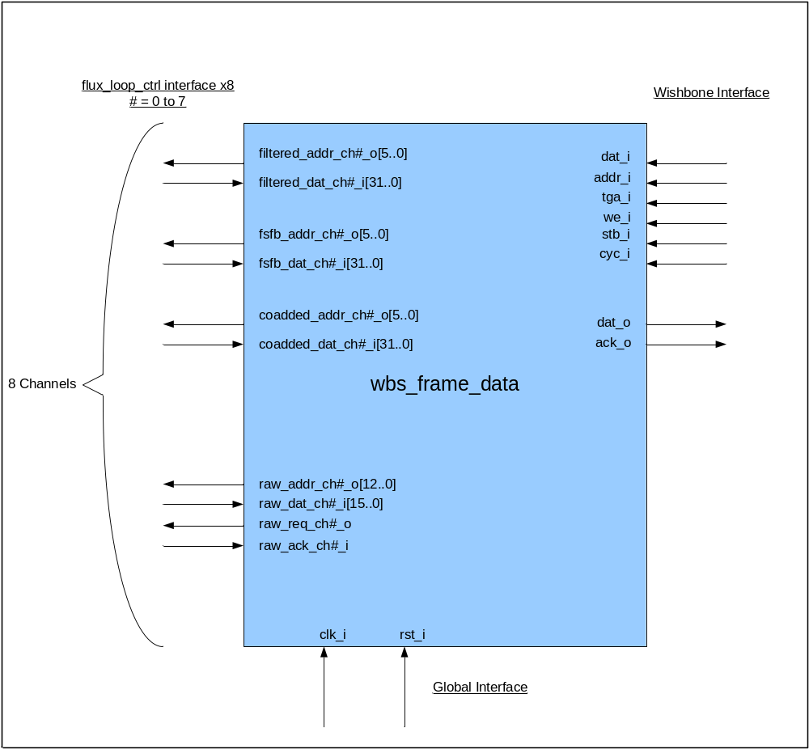
Figure 1: block dataflow

Wishbone Requests
This block has to respond to the following three wishbone requests:
1. Data Mode
Data mode is a wishbone write request, which results in the data word on the wishbone interface field dat_i being registered. This registered word determines the nature of the data that will be read by the wishbone master in subsequent return data read requests. The wishbone interface timing diagram for this instruction is provided in Figure 2.

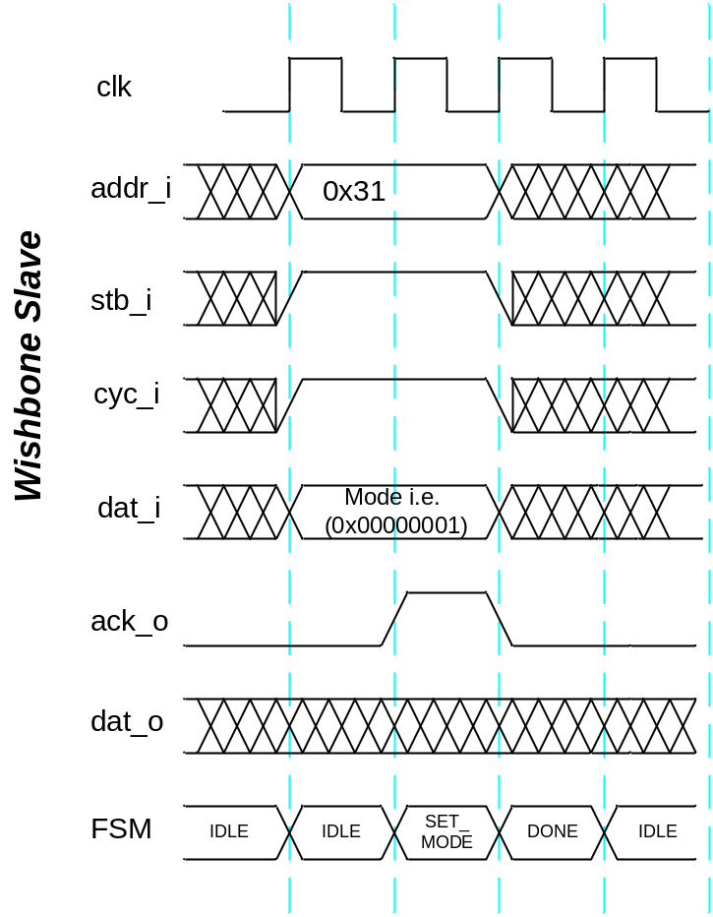
Figure 2: Data Mode wishbone write timing Diagram

As revealed in Table 1, there are four possible data modes: filtered feedback data; unfiltered feedback data; combined error and feedback data; and raw sampled data. The least two significant bits of the registered data mode word are used as a multiplexer selector (data_out_mux_sel) to path the correct data type to the wishbone interface field dat_o. An illustration of this is revealed in Section 2.2.

Mode | Registered dat_i selector | Data Type | Subsequent Read Data Format
1 | 0x00000000 | Filtered Feedback | filtered_dat_i(31..0)
2 | 0x00000001 | Unfiltered Feedback | fsfb_dat_i (31..0)
3 | 0x00000002 | Combined Error and Feedback | fsfb_dat_i (31..16) & coadded_dat_i (31..16)
4 | 0x00000003 | Raw Sampled | raw_dat_i(15..0), zero extended
Table 1 : Data Modes
Note that the block is coded to respond to a read data_mode instruction. Here the registered value is returned on the dat_o field.

2. Return Data
A ret_dat command from the clock card instructs the wishbone master (dispatch) to read 328 words from wbs_frame_data, which it does by issuing a return data wishbone instruction. This is implemented as a block read by ‘wbs_frame_data’, the timing of which is revealed in Figure 3.

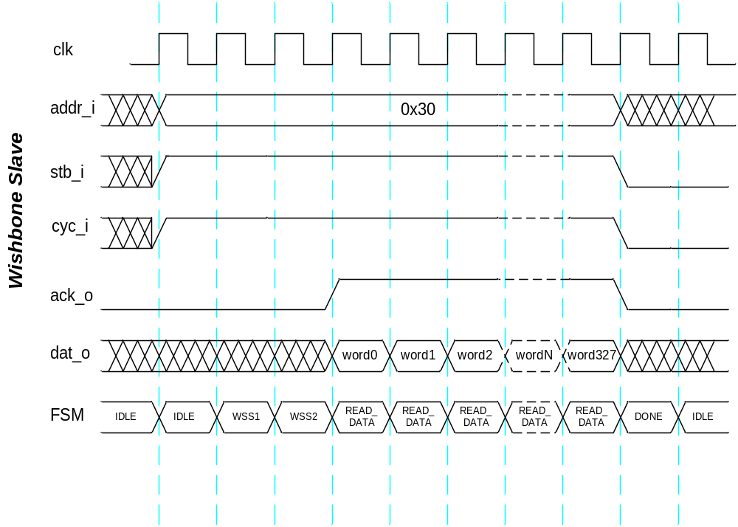
Figure 3: return_data wishbone block read timing diagram

On receiving a block read request wbs_frame_data inserts a couple of slave wait states (by keeping ack_o low) before it makes the data available. This is due to the time it take to address the data in the flux_loop_ctrl blocks. Note that the master can insert wait states at any time during the read block cycle by de-asserting stb_i.. When this occurs the ack_o signal is de-asserted and data reading is postponed until two clock cycles after the stb_i signal is reasserted.

As previously discussed the nature of the data read by the wishbone master is determined by the value written to the slave during the last data mode write instruction. All ret_data read blocks return 328 words of data (41rows * 8 channels). For modes 1,2 and 3 the data is returned in the following sequence:
Ret_data sequence (modes 1,2 and 3):

(Row 0, channel 0), (Row 0, channel 1), (Row 0, channel 2), ------ , (Row 0, channel 7),
(Row 1, channel 0), (Row 1, channel 1), (Row 1, channel 2), ------ , (Row 1, channel 7),
(Row 2, channel 0), (Row 2, channel 1), (Row 2, channel 2), ------ , (Row 2, channel 7),
--
--
(Row 40, channel 0), (Row 40, channel 1), (Row 40, channel 2), ---- , (Row 40, channel 7),

When in raw data mode there are two frames of data to be read and 64 samples for each pixel. Subsequently it can be considered that there are 64*2*41 = 5248 ‘rows’ to be read, giving a total of 5248 x 8 = 41984 data values. Each ret_data instruction reads 328 values (41 ‘rows’ * 8 channels) . Consequently, 41984/328 = 128 ret_data read instructions are required to read a ‘frame’ of raw data.

Ret_data sequence (modes 4):
Ret_data #1: (‘Row 0’, channel 0) → (‘Row 40’, channel 7)
Ret_data #2: (‘Row 41’, channel 0) → (‘Row 81’, channel 7)
Ret_data #3: (‘Row 82’, channel 0) → (‘Row 122’, channel 7)
--
--
Ret_data #128: (‘Row 5207’, channel 0) → (‘Row 5247’, channel 7)

Note that the block is also coded to acknowledge a write ret_data instruction. This would only ever occur in error, however, wbs_frame_data must acknowledge the instruction to prevent the system from hanging.
3. Capture Raw
Capture Raw is a wishbone write request. It results in a control signal (raw_req_ch#_i) being asserted for each of the eight flux_loop_cntr blocks. Each of the blocks will acknowledge when they have collected the raw data by asserting their raw_ack_ch#_i signal. Once all eight blocks have responded the slave acknowledges (by asserting ack_o) that the wishbone instruction is complete.

Note that the block is coded to respond to a read captr_raw instruction. Here the instruction is just acknowledged and a data value of 0 is returned on dat_o. This is required to prevent the system from hanging should this meaningless instruction be issued.

Block Interfaces

Interface Signal Description
- Interface Signals
Signal | Description | Direction
Global Signals
clk_i | Global clock signal | in
rst_i | Global asynchronous active-high reset | in
Flux Loop Control Interface (x8) | ch# = ch0 → ch7
filtered_addr_ch#_o | Channel # row address of filtered data (range 0..40) | out
filtered_dat_ch#_i | Channel # filtered data | in
fsfb_addr_ch#_o | Channel # row address of unfiltered feedback data (range 0..40) | out
fsfb_dat_ch#_i | Channel # feedback data | in
coadded_addr_ch#_o | Channel # row address of coadded error data (range 0..40) | out
coadded_addr_ch#_i | Channel # coadded error data | in
raw_addr_ch#_o | Channel # sample address of raw data (range 0..5247) | out
raw_dat_ch#_i | Channel # raw data sample | in
raw_req_ch#_o | Channel # request to start taking 2 frames of raw data | out
raw_ack_ch#_i | Channel # acknowledgement that 2 frames worth of raw data has been collated. | in
Wishbone Interfaces
dat_i | Wishbone data in | in
addr_i | Wishbone address in (used to target slave and identify operation) | in
tga_i | - unused | in
we_i | Wishbone Write / not read enable | in
stb_i | Wishbone stobe | in
cyc_i | Wishbone cycle | in
dat_o | Wishbond data out | out
ack_o | Wishbone acknowledge | out

Data output MUX architecture

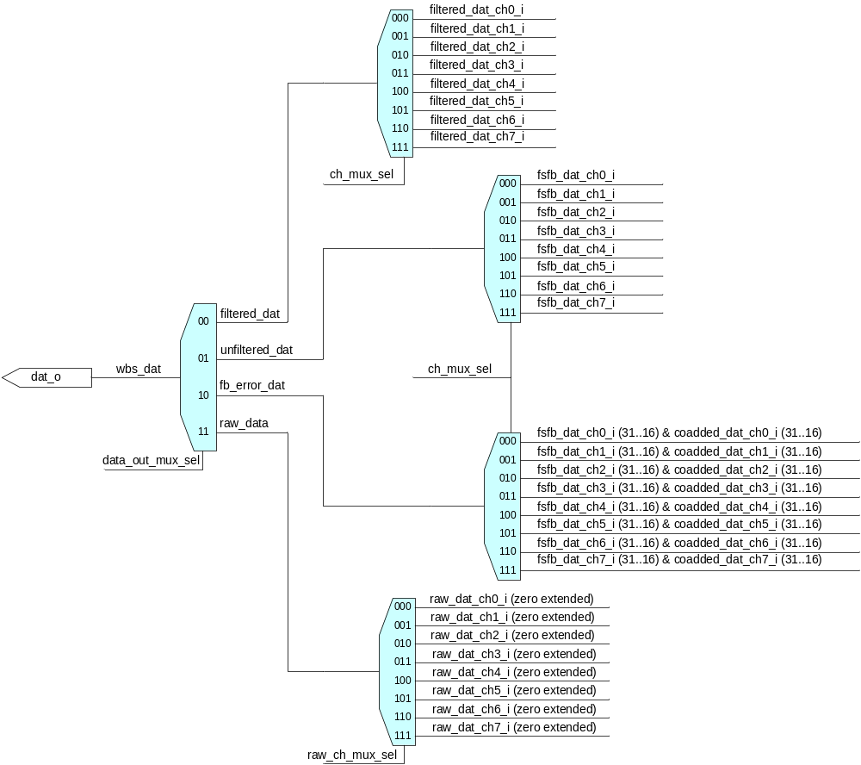

Interface Protocol and Timing

High-Level Description

State Machine Description
A state machine is used to decide what actions need to be taken in response to read/write requests on the wishbone interface. The state transition diagram is shown below.
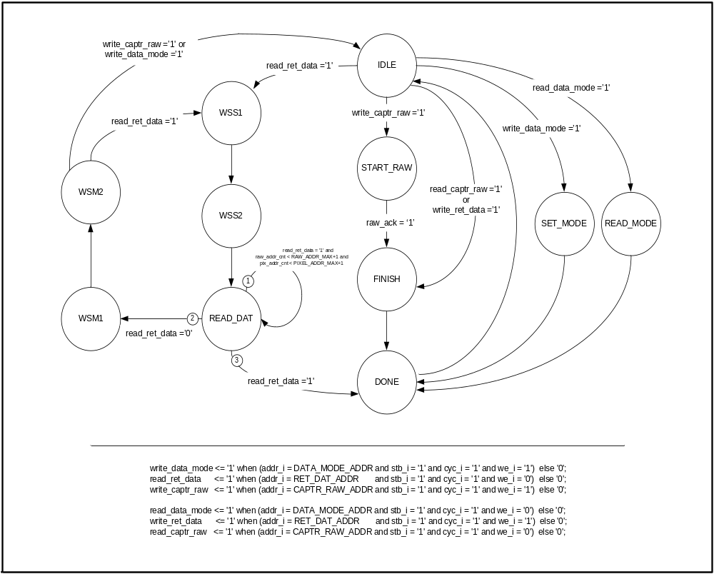

State Machine Outputs
There are eight outputs for this FSM. They are: dat_rdy – indicates data word is ready to be read by wishbone master; intsr_done – indicates non-data read instruction is finished and can be acknowledged; dat_o - wishbone data output; data_mode_mux_sel – recirculation MUX selector used to register the data mode word; inc_add_ena – address counter synchronous increment enable; dec_add_sel – address counter synchronous decrement enable; rst_add_sel – address counter synchronous reset enable; raw_req – request eight flux_loop_cntr blocks to collect two frames worth of raw data.

STATE | OUTPUTS
IDLE | dat_rdy <= '0';  instr_done <= '0';  dat_o <= (others => '0');  data_mode_mux_sel <= '0';  inc_addr_ena <= '0';  dec_addr_ena <= '0';  rst_addr_ena <= '1';  raw_req <= '0';
SET_MODE | dat_rdy <= '0';  instr_done <= '1';  dat_o <= (others => '0');  data_mode_mux_sel <= '1';  inc_addr_ena <= '0';  dec_addr_ena <= '0';  rst_addr_ena <= '0';  raw_req <= '0';
READ_MODE | dat_rdy <= '0';  instr_done <= '1';  dat_o <= data_mode_reg;  data_mode_mux_sel <= '0';  inc_addr_ena <= '0';  dec_addr_ena <= '0';  rst_addr_ena <= '0';  raw_req <= '0';
WSS1 | dat_rdy <= '0';  instr_done <= '0';  dat_o <= (others => '0');  data_mode_mux_sel <= '0';  inc_addr_ena <= '1';  dec_addr_ena <= '0';  rst_addr_ena <= '0';  raw_req <= '0';
WSS2 | dat_rdy <= '0';  instr_done <= '0';  dat_o <= (others => '0');  data_mode_mux_sel <= '0';  inc_addr_ena <= '0';  dec_addr_ena <= '0';  rst_addr_ena <= '0';  raw_req <= '0';
READ_DATA | dat_rdy <= '1';  instr_done <= '0';  dat_o <= wbs_data;  data_mode_mux_sel <= '0';  inc_addr_ena <= '1';  dec_addr_ena <= '0';  rst_addr_ena <= '0';  raw_req <= '0';
WSM1 | dat_rdy <= '0';  instr_done <= '0';  dat_o <= (others => '0');  data_mode_mux_sel <= '0';  inc_addr_ena <= '0';  dec_addr_ena <= '1';  rst_addr_ena <= '0';  raw_req <= '0';
WSM2 | dat_rdy <= '0';  instr_done <= '0';  dat_o <= (others => '0');  data_mode_mux_sel <= '0';  inc_addr_ena <= '0';  dec_addr_ena <= '0';  rst_addr_ena <= '0';  raw_req <= '0';
START_RAW | dat_rdy <= '0';  instr_done <= '0';  dat_o <= (others => '0');  data_mode_mux_sel <= '0';  inc_addr_ena <= '0';  rst_addr_ena <= '0';  raw_req <= '1';
FINISH | dat_rdy <= '0';  instr_done <= '1';  dat_o <= (others => '0');  data_mode_mux_sel <= '0';  inc_addr_ena <= '0';  dec_addr_ena <= '0';  rst_addr_ena <= '0';  raw_req <= '0';
DONE | dat_rdy <= '0';  instr_done <= '0';  dat_o <= (others => '0');  data_mode_mux_sel <= '0';  inc_addr_ena <= '0';  dec_addr_ena <= '0';  rst_addr_ena <= '0';  raw_req <= '0';

Files of the Block

Source Code

Wbs_frame_data.vhd

Header Code

Wishbone_pack.vhd

